|  |
| --- |
| Experiment No. 8 |
| Creating GUI with python containing widgets such as labels, textbox, radio, checkboxes and custom dialog boxes |
| Date of Performance: 20/03/2024 |
| Date of Submission: 26/03/2024 |

**Experiment No. 8**

**Title:** Creating GUI with python containing widgets such as labels, textbox, radio, checkboxes and custom dialog boxes

**Aim:** To study and create GUI with python containing widgets such as labels, textbox, radio, checkboxes and custom dialog boxes

**Objective:** To introduce GUI, TKinter in python

**Theory:**

Python offers multiple options for developing GUI (Graphical User Interface). Out of all the GUI methods, tkinter is the most commonly used method. It is a standard Python interface to the Tk GUI toolkit shipped with Python. Python with tkinter is the fastest and easiest way to create the GUI applications. Creating a GUI using tkinter is an easy task.

To create a tkinter app:

Importing the module – tkinter

Create the main window (container)

Add any number of widgets to the main window

Apply the event Trigger on the widgets.

Importing tkinter is same as importing any other module in the Python code. Note that the name of the module in Python 2.x is ‘Tkinter’ and in Python 3.x it is ‘tkinter’.

**Code:**

import tkinter as tk

from tkinter import *

r = tk.Tk()

r.title('Anjali GUI')

# Canvas

canvas_height = 20

canvas_width = 200

canvas = tk.Canvas(r, width=canvas_width, height=canvas_height)

canvas.pack()

y = int(canvas_height / 2)

canvas.create_line(0, y, canvas_width, y)

# Entry

name= tk.Label(r,text=" FirstName:");

name= tk.Label(r,text="LastName:");

name.grid(row=0,column=0,padx=10,pady=0,sticky="e");

name_entry = tk.Entry(r)

name_entry.grid(row=0, column=1, padx=10, pady=5)

# Checkboxes

var1 = IntVar()

Checkbutton(r, text='Male', variable=var1, anchor=W).pack()

var2 = IntVar()

Checkbutton(r, text='Female', variable=var2, anchor=W).pack()

# Button to stop

button = tk.Button(r, text='Click here to Stop', width=20, command=r.destroy)

button.pack()

r.mainloop()

**Output:**

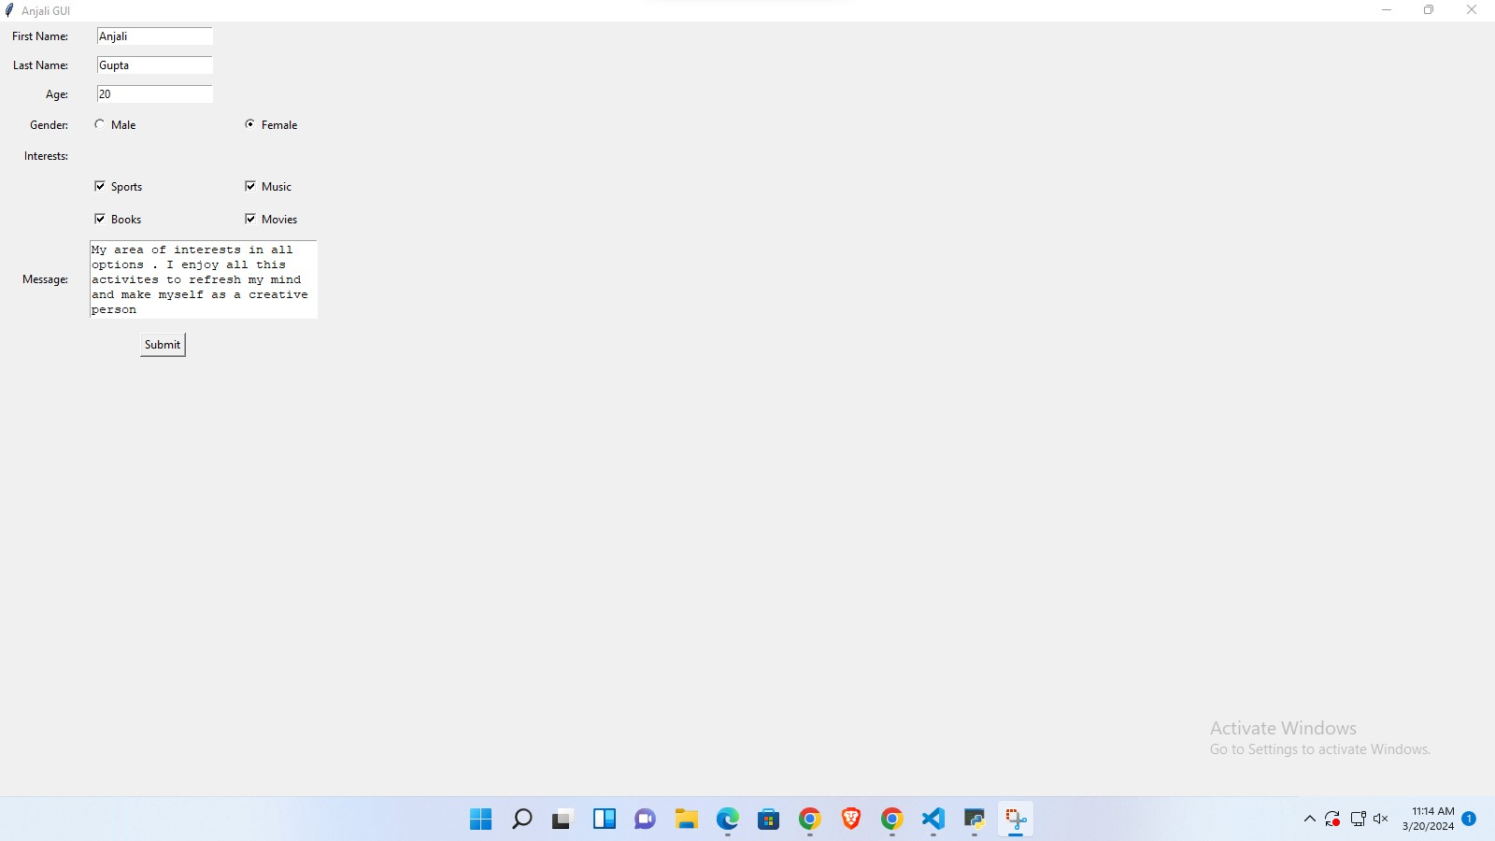

**Conclusion:**

Tkinter is the standard GUI (Graphical User Interface) toolkit for Python. It provides a simple and easy-to-use interface for creating GUI applications. Tkinter is based on the Tk GUI toolkit, which originated as a part of the Tcl (Tool Command Language) scripting language.

Tkinter comes bundled with Python, so there's no need to install any additional libraries to use it. It provides a set of widgets (UI elements) that can be used to create various types of windows, dialogs, buttons, menus, text boxes, and more.

Widgets are the building blocks of a Tkinter GUI application. Each widget represents a graphical component such as a button, label, entry field, or frame. Tkinter provides three geometry managers to arrange widgets within a window: pack, grid, and place.